
Stanley Road Curriculum (2 Year Cycle)

 |  |  | Term 1 |  |  |  |  | Term 2 |  |  |  | Term 3
N/R Cycle A | Main project |  |   Me and My Community |  |  |  |   Once Upon  a Time |   Starry Night |  | 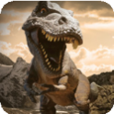  Dangerous Dinosaurs |  |   Sunshine and Sunflowers | 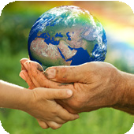 Big Wide World
N/R Cycle A | Mini project |  | Exploring Autumn |  |  |  | Sparkle and Shine | Winter Wonderland |  | Puddles and Rainbows |  | Shadows and Reflections | Splash!
N/R Cycle B | Main project |  | 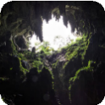  Let’s Explore |  |  |  |   Marvellous Machines | 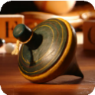  Long Ago |  | 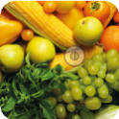  Ready Steady Grow |  | 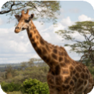  Animal Safari | 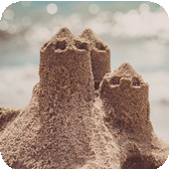 On the Beach
N/R Cycle B | Mini project |  | Build It Up |  |  |  | Puppets and Pop Ups | Stories and Rhymes |  | Signs of Spring |  | Creep, Crawl and Wriggle | Move It | Moving On
Y1/2 Cycle A | Main project |  | 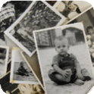 |  | Childhood  History |  |  | 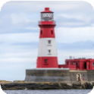  Coastline  Geography |  |  |  | 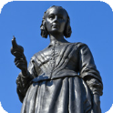  Movers and Shakers  History
Y1/2 Cycle A | Mini projects | Science* | Everyday materials |  |  |  | Humans | Uses of everyday materials | Plants |  |  | Humans | Living things and their habitats
Y1/2 Cycle A | Mini projects | A&D | Mix It (Y1) |  |  |  | Funny Faces and Fabulous Features | Flower Head |  |  |  | Mix It (Y2) | Still Life
Y1/2 Cycle A | Mini projects | D&T | Shade and Shelter |  |  |  |  | Beach Hut |  |  |  | Remarkable Recipes
Y1/2 Cycle A | Mini projects | Geography | Our Wonderful World |  |  |  |  | Geography covered in the main project |  |  |  | Let’s Explore the World
 |  | RE | 1.1 What do Christians believe God is like? |  |  | 1.3 Why does Christmas matter to Christians? |  | 1.9 How should we care for others and for the world, and why does it matter? | 1.5 Why does Easter matter to Christians? |  |  | 1.7 Who is Jewish and how do they live? [Double unit] | 1.7 Who is Jewish and how do they live? [Double unit]
Y1/2 Cycle B | Main project |  | 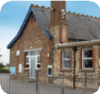  School Days  History |  |  |  |  |   Bright Lights, Big City  Geography |  |  |  | 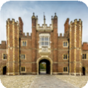  Magnificent Monarchs  History
Y1/2 Cycle B | Mini projects | Science* | Plants |  |  |  | Animals | Seasonal changes |  |  |  | Animals
Y1/2 Cycle B | Mini projects | A&D | Street View |  |  |  |  | Rain and Sunrays |  |  |  | Portraits and Poses
Y1/2 Cycle B | Mini projects | D&T | Chop, Slice and Mash |  |  |  |  | Taxi! |  |  |  | Making It Move
Y1/2 Cycle B | Mini projects | Geography | Geography revision and retrieval practice |  |  |  |  | Geography covered in the main project |  |  |  | Geography revision and retrieval practice
 |  | RE | 1.2 Who do Christians say made the world? |  |  | 1.4 What is the ‘good news’ Christians believe Jesus brings? |  | 1.6 Who is a Muslim and how do they live? [Double unit] | 1.6 Who is a Muslim and how do they live? [Double unit] |  |  | 1.8 What makes some places sacred to believers? | 1.10 What does it mean to belong to a faith community?

 |  |  | Term 1 |  |  |  |  | Term 2 |  |  |  | Term 3
Y3/4 Cycle A | Main project |  |  | 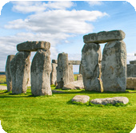 | Through the Ages  History |  |  |  | 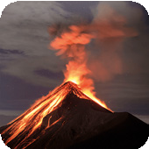 |  | Rocks, Relics and Rumbles  Geography |  |  | 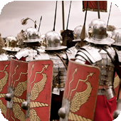 | Emperors and Empires  History
Y3/4 Cycle A | Mini projects | Science* | Animals, including humans |  |  |  |  | Forces and magnets |  |  |  | Plants |  |  | Light
Y3/4 Cycle A | Mini projects | A&D | Contrast and Complement (Y3) |  | Prehistoric Pots |  |  | Ammonite |  |  | People and Places | Beautiful Botanicals |  |  | Mosaic Masters
Y3/4 Cycle A | Mini projects | D&T | Cook Well, Eatwell |  |  |  |  | Making it Move |  |  |  | Greenhouse
Y3/4 Cycle A | Mini projects | Geography | One Planet, Our World |  |  |  |  | Geography covered in the main project |  |  |  | Geography revision and retrieval practice
 |  | RE | L2.1 What do Christians learn from the Creation story? |  |  | L2.3 What is the ‘Trinity’ and why is it important for Christians? |  | L2.5 Why do Christians call the day Jesus died ‘Good Friday’? |  | L2.7 What do Hindus believe God is like? |  | L2.9 How do festivals and worship show what matters to Muslims? |  |  | L2.11 How and why do people mark the significant events of life? Christians, Hindus, Muslims, non-religious
Y3/4 Cycle B | Main project |  |  | 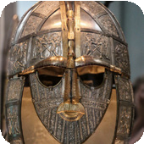 | Invasion  History |  |  |  | 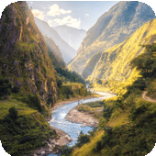 |  | Misty Mountain, Winding River  Geography |  |  | 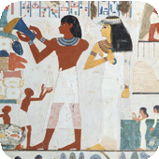 | Ancient Civilisations  History
Y3/4 Cycle B | Mini projects | Science* | Animals, including humans |  | Sound |  |  | States of matter |  |  | Living things and their habitats | Electricity
Y3/4 Cycle B | Mini projects | A&D | Contrast and Complement (Y4) |  | Warp and Weft |  |  | Vista |  |  | Animal | Statues, Statuettes and Figurines |  |  | Islamic Art
Y3/4 Cycle B | Mini projects | D&T | Fresh Food, Good Food |  |  |  |  | Functional and Fancy Fabrics |  |  |  | Tomb Builders
Y3/4 Cycle B | Mini projects | Geography | Interconnected World |  |  |  |  | Geography covered in the main project |  |  |  | Geography revision and retrieval practice
 |  | RE | L2.2 What is it like for someone to follow God? |  |  | L2.4 What kind of world did Jesus want? |  | L2.6 For Christians, what was the impact of Pentecost? |  | L2.8 What does it mean to be Hindu in Britain today? |  | L2.10 How do festivals and family life show what matters to Jewish people? |  |  | L2.12 How and why do people try to make the world a better place? Christians, Muslims, non-religious

 |  |  | Term 1 |  |  |  |  |  |  | Term 2 |  |  |  | Term 3
Year 5 | Main project |  |  |  | 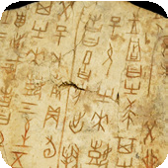 | Dynamic Dynasties  History |  |  |  |  | 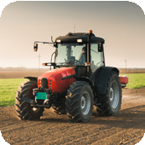 |  | Sow, Grow and Farm  Geography |  |  | 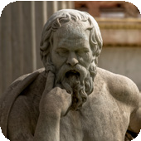 | Groundbreaking Greeks  History
Year 5 | Mini projects | Science* | Forces |  |  | Earth and space |  |  |  | Animals, including humans |  |  |  | Properties and changes of materials
Year 5 | Mini projects | A&D | Tints, Tones and Shades (Y5) |  |  | Taotie |  |  |  | Line, Light and Shadows |  |  | Nature’s Art | Mix Media |  |  | Figures and Forms
Year 5 | Mini projects | D&T | Moving Mechanisms |  |  |  |  |  |  | Eat the Seasons |  |  |  | Architecture
Year 5 | Mini projects | Geography | Investigating Our World |  |  |  |  |  |  | Geography covered in the main project |  |  |  | Geography revision and retrieval practice
 |  | RE | U2.1 What does it mean if Christians believe God is holy and loving? |  |  |  | U2.3 Why do Christians believe Jesus was the Messiah? |  |  | U2.5 What do Christians believe Jesus did to ‘save’ people? |  | U2.7 Why do Hindus want to be good? |  | U2.9 Why is the Torah so important to Jewish people? |  |  | U2.11 Why do some people believe in God and some people not? Christians, non-religious
Year 6 | Main project |  |  |  | 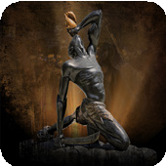 | Maafa  History |  |  |  |  | 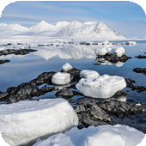 |  | Frozen Kingdoms  Geography |  |  | 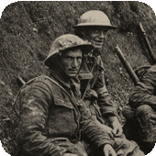 | Britain at War  History
Year 6 | Mini projects | Science* | Animals, including humans |  |  |  |  |  |  | Electricity |  |  |  | Light |  |  | Evolution and inheritance
Year 6 | Mini projects | A&D | Tints, Tones and Shades (Y6) |  |  | Trailblazers, Barrier Breakers |  |  |  | Inuit |  |  | Environmental Artists | Distortion and Abstraction |  |  | Bees, Beetles and Butterflies
Year 6 | Mini projects | D&T | Food for Life |  |  |  |  |  |  | Engineer |  |  |  | Make Do and Mend
Year 6 | Mini projects | Geography | Our Changing World |  |  |  |  |  |  | Geography covered in the main project |  |  |  | Geography revision and retrieval practice
 |  | RE | U2.2 Creation and science: conflicting or complementary? |  |  |  | U2.4 How do Christians decide how to live? ‘What would Jesus do?’ |  |  | U2.6 For Christians, what kind of king is Jesus? |  | U2.8 What does it mean to be a Muslim in Britain today? |  | U2.10 What matters most to Humanists, Christians? Christians and non-religious, with opportunities to include other faiths studied |  |  | U2.12 How does faith help people when life gets hard? Christians, Muslims and/or Jews and/or Hindus, non-religious

